Naïve Bayes Classification on the Bank Marketing Dataset

Introduction
The objective of this project was to develop and evaluate a Gaussian Naive Bayes classifier using the Bank Marketing dataset. The dataset contains 17 columns, including customer demographic, financial, and campaign-related information collected during direct marketing campaigns conducted by a banking institution. The target variable, y, indicates whether a customer subscribed to a term deposit.
The experiment involved preparing the dataset, training and testing a Gaussian Naive Bayes model, evaluating its performance using Accuracy and F1-score metrics, and investigating the effect of different training data proportions on classification performance.

Data Preparation
The Bank Marketing Dataset was loaded into a Pandas DataFrame named df. Several variables in the dataset contained categorical values, and therefore, I converted them into numeric form before model training.
The following categorical variables were mapped to integer values:
- Job
- Marital
- Education
- Default
- Housing
- Loan
- Contact
- Month
- Poutcome
- Y
Any rows containing missing values were removed from the dataset. The dataset was then separated into:
- X: all feature variables
- y: the target variable
The data was prepared for machine learning by ensuring all predictor variables were represented numerically.
Another preprocessing step was checking for missing values and, if necessary, removing rows containing NA values. After preprocessing, all features used by the model were numeric. The predictor variables were stored in X, while the target variable y was stored separately.
Working with the dataset also required ensuring the correct dataset file was loaded and that the semicolon separator was handled correctly. Once these preprocessing steps were completed, the dataset was ready for model training and testing.

Task II: Gaussian Naïve Bayes Model
A Gaussian Naïve Bayes classifier was created using Scikit-Learn's GaussianNB() function.
The dataset was split into:
- 70% training data
- 30% testing data
Stratified random sampling was used to preserve the original class distribution of the target variable.
The model was trained using the training dataset and then evaluated on the testing dataset. Performance was measured using Accuracy and Weighted F1-score. The experiment was repeated ten times using different random states to ensure reliable performance estimates.

Results for 70/30 Split
Trial | Accuracy | F1 Score
1 | 0.8425 | 0.8533
2 | 0.8427 | 0.8529
3 | 0.8460 | 0.8554
4 | 0.8440 | 0.8545
5 | 0.8486 | 0.8584
6 | 0.8414 | 0.8520
7 | 0.8482 | 0.8571
8 | 0.8501 | 0.8595
9 | 0.8427 | 0.8533
10 | 0.8433 | 0.8541

Summary Statistics
Metric | Mean | Standard Deviation
Accuracy | 0.8450 | 0.0029
F1 Score | 0.8551 | 0.0024

Confusion Matrix

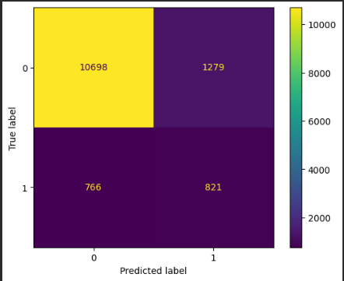

The confusion matrix provides additional information about how predictions are distributed between the two target classes. This is useful because Accuracy alone does not show which classes are being classified correctly or incorrectly.

Task III: The Training Dataset Results
The second part of the experiment investigated whether increasing the amount of training data improved the classification performance.
Nine different training/testing proportions were examined:
- 10% training / 90% testing
- 20% training / 80% testing
- 30% training / 70% testing
- 40% training / 60% testing
- 50% training / 50% testing
- 60% training / 40% testing
- 70% training / 30% testing
- 80% training / 20% testing
- 90% training / 10% testing
Each proportion was tested across ten different random states.

Results
LearningTraining % | Testing % | Mean Accuracy | Std Accuracy | Mean F1 | Std F1
10 | 90 | 0.8473 | 0.0061 | 0.8563 | 0.0039
20 | 80 | 0.8446 | 0.0054 | 0.8546 | 0.0043
30 | 70 | 0.8442 | 0.0059 | 0.8542 | 0.0047
40 | 60 | 0.8463 | 0.0055 | 0.8560 | 0.0044
50 | 50 | 0.8459 | 0.0044 | 0.8558 | 0.0034
60 | 40 | 0.8451 | 0.0037 | 0.8552 | 0.0028
70 | 30 | 0.8450 | 0.0029 | 0.8551 | 0.0024
80 | 20 | 0.8462 | 0.0040 | 0.8561 | 0.0035
90 | 10 | 0.8458 | 0.0054 | 0.8555 | 0.0046

Performance Plot:
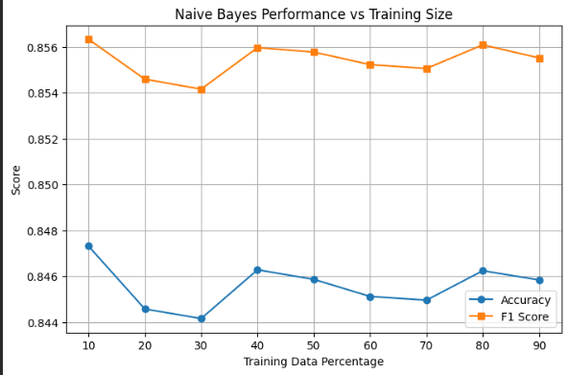

Findings/Conclusion
The Gaussian Naive Bayes classifier produced highly stable results across all training and testing proportions. Mean Accuracy remained between approximately 84.4% and 84.7%, while Mean F1-score remained between approximately 85.4% and 85.6%.
One interesting observation is that increasing the amount of training data did not significantly improve predictive performance. Normally, larger training datasets help machine learning models learn more complex patterns and improve accuracy. However, in this experiment, performance remained nearly constant regardless of the amount of training data used.
A possible explanation is that the Bank Marketing dataset contains over 45,000 observations. Even when I used only 10% of the dataset for training, the model still had roughly 4,500 training examples. This appears to have been sufficient for the Gaussian Naive Bayes classifier to learn the major relationships within the data. Consequently, adding more training data produced only marginal changes in performance.
Another notable observation is the behavior of the standard deviation values. Although the changes were relatively small, the standard deviation generally decreased as the amount of training data increased from 10% to around 70%. This suggests that the classifier became more stable when trained on larger samples. With additional training observations, the model became less sensitive to random train-test splits, resulting in more consistent performance across iterations.
The highest mean accuracy (0.8473) and F1-score (0.8563) occurred with the 10% training split. However, this does not necessarily indicate that a smaller training set produces a better model. The difference between the highest and lowest performance values was less than 0.5%, which is comparable to the observed standard deviations. Therefore, these variations are most likely due to random sampling effects rather than a genuine performance improvement.
Moreover, the results show that Gaussian Naive Bayes provides consistent, reliable classification performance on the Bank Marketing dataset. The classifier was able to achieve similar results across a wide range of training dataset sizes, indicating robustness and stability.
Overall, after processing the data and converting categorical variables into numerical form, the classifier achieved a mean accuracy of approximately 84.5% and a mean weighted F1-score of 85.5%.
Experimenting with different training data proportions showed that the model’s performance remained stable, even when I trained on relatively small subsets of the data. The low standard deviations across all experiments indicate that the classifier is robust and produces consistent results across different random train-test splits.

